**AC 1**

1. Transform the following complex numbers into trigonometric and exponential form:

$${\text{a) }\underline{\text{Z}}}_{\text{1}}\text{=1+j}\text{;}{\text{b) }\underline{\text{Z}}}_{\text{2}}\text{=-1+j}\text{; }{\text{c) }\underline{\text{Z}}}_{\text{3}}\text{=-1-j; }{\text{d) }\underline{\text{Z}}}_{\text{e}}\text{=1-j.}$$

$${\text{a)}\underline{\text{Z}}}_{\text{1}}\text{=1+j}\text{.}$$

The module of the complex number is ${\underline{\text{Z}}}_{\text{1}}$ is:

${\text{r}}_{\text{1}}\text{=}\sqrt{{\text{a}}_{\text{1}}^{\text{2}}\text{+}{\text{b}}_{\text{1}}^{\text{2}}}\text{=}\sqrt{\text{2}}$. $\left\{\begin{aligned}\text{cos}{\text{α}}_{\text{1}}\text{=}\frac{{\text{a}}_{\text{1}}}{{\text{r}}_{\text{1}}}\text{=}\frac{\text{1}}{\sqrt{\text{2}}}\text{=}\frac{\sqrt{\text{2}}}{\text{2}}\text{;} \\ \text{sin}{\text{α}}_{\text{1}}\text{=}\frac{{\text{b}}_{\text{1}}}{{\text{r}}_{\text{1}}}\text{=}\frac{\text{1}}{\sqrt{\text{2}}}\text{=}\frac{\sqrt{\text{2}}}{\text{2}}\text{.}\end{aligned}\text{→}{\text{α}}_{\text{1}}\text{∈}\text{[0,}\frac{\text{π}}{\text{2}}\text{]; }{\text{α}}_{\text{1}}\text{=}\frac{\text{π}}{\text{4}}\text{. }\right.$

$$\text{1+j=}\sqrt{\text{2}}\text{(cos }\frac{\text{π}}{\text{4}}\text{+jsin}{\frac{\text{π}}{\text{4}}}\text{)=}\sqrt{\text{2}}{{\text{e}}^{\text{j}\frac{\text{π}}{\text{4}}}}.$$

$${\text{b)}\underline{\text{Z}}}_{\text{2}}\text{=}\text{-}\text{1+j}\text{.}$$

${\text{r}}_{\text{2}}\text{=}\sqrt{{\text{a}}_{\text{2}}^{\text{2}}\text{+}{\text{b}}_{\text{2}}^{\text{2}}}\text{=}\sqrt{\text{2}}$. $\left\{\begin{aligned}\text{cos}{\text{α}}_{\text{2}}\text{=}\frac{{\text{a}}_{\text{2}}}{{\text{r}}_{\text{2}}}\text{=}\frac{\text{-1}}{\sqrt{\text{2}}}\text{=-}\frac{\sqrt{\text{2}}}{\text{2}}\text{;} \\ \text{sin}{\text{α}}_{\text{2}}\text{=}\frac{{\text{b}}_{\text{2}}}{{\text{r}}_{\text{2}}}\text{=}\frac{\text{1}}{\sqrt{\text{2}}}\text{=}\frac{\sqrt{\text{2}}}{\text{2}}\text{.}\end{aligned}\text{→}{\text{α}}_{\text{2}}\text{∈}\text{[}\frac{\text{π}}{\text{2}}\text{, π]; }{\text{α}}_{\text{2}}\text{=π-}\frac{\text{π}}{\text{4}}\text{= }\frac{\text{3π}}{\text{4}}\right..$

$$\text{-1+j=}\sqrt{\text{2}}\text{(cos }\frac{\text{3π}}{\text{4}}\text{+jsin}{\frac{\text{3π}}{\text{4}}}\text{)=}\sqrt{\text{2}}{{\text{e}}^{\text{j}\frac{\text{3π}}{\text{4}}}}.$$

$${\text{c)}\underline{\text{Z}}}_{\text{3}}\text{=}\text{-}\text{1-j}\text{.}$$

${\text{r}}_{\text{3}}\text{=}\sqrt{{\text{a}}_{\text{3}}^{\text{2}}\text{+}{\text{b}}_{\text{3}}^{\text{2}}}\text{=}\sqrt{\text{2}}$.

$$\left\{\begin{aligned}\text{cos}{\text{α}}_{\text{3}}\text{=}\frac{{\text{a}}_{\text{3}}}{{\text{r}}_{\text{3}}}\text{=}\frac{\text{-1}}{\sqrt{\text{2}}}\text{=-}\frac{\sqrt{\text{2}}}{\text{2}}\text{;} \\ \text{sin}{\text{α}}_{\text{3}}\text{=}\frac{{\text{b}}_{\text{3}}}{{\text{r}}_{\text{3}}}\text{=}\frac{\text{-1}}{\sqrt{\text{2}}}\text{=-}\frac{\sqrt{\text{2}}}{\text{2}}\text{.}\end{aligned}\text{→}{\text{α}}_{\text{3}}\text{∈}\text{[π,}\frac{\text{3π}}{\text{2}}\text{]; }{\text{α}}_{\text{3}}\text{=π+}\frac{\text{π}}{\text{4}}\text{=}\frac{\text{5π}}{\text{4}}\text{. }\right.$$

$$\text{-}\text{1-j=}\sqrt{\text{2}}\text{(cos }\frac{\text{5}\text{π}}{\text{4}}\text{+jsin}{\frac{\text{5}\text{π}}{\text{4}}}\text{)=}\sqrt{\text{2}}{{\text{e}}^{\text{j}\frac{\text{5}\text{π}}{\text{4}}}}.$$

$${\text{d)} \underline{\text{Z}}}_{\text{4}}\text{=1-j}\text{.}$$

${\text{r}}_{\text{4}}\text{=}\sqrt{{\text{a}}_{\text{4}}^{\text{2}}\text{+}{\text{b}}_{\text{4}}^{\text{2}}}\text{=}\sqrt{\text{2}}$. $\left\{\begin{aligned}\text{cos}{\text{α}}_{\text{4}}\text{=}\frac{{\text{a}}_{\text{4}}}{{\text{r}}_{\text{4}}}\text{=}\frac{\text{1}}{\sqrt{\text{2}}}\text{=}\frac{\sqrt{\text{2}}}{\text{2}}\text{;} \\ \text{sin}{\text{α}}_{\text{4}}\text{=}\frac{{\text{b}}_{\text{4}}}{{\text{r}}_{\text{4}}}\text{=}\frac{\text{-1}}{\sqrt{\text{2}}}\text{=-}\frac{\sqrt{\text{2}}}{\text{2}}\text{.}\end{aligned}\text{→}{\text{α}}_{\text{4}}\text{∈}\text{[}\frac{\text{3π}}{\text{2}}\text{, 2π]; }{\text{α}}_{\text{4}}\text{=2π-}\frac{\text{π}}{\text{4}}\text{=}\frac{\text{7π}}{\text{4}}\text{. }\right.$

$$\text{1-j=}\sqrt{\text{2}}\text{(cos }\frac{\text{7π}}{\text{4}}\text{+jsin}{\frac{\text{7π}}{\text{4}}}\text{)=}\sqrt{\text{2}}{{\text{e}}^{\text{j}\frac{\text{7π}}{\text{4}}}}.$$

1. Determine the instantaneous values of the complex currents knowing that the frequency is f=50 Hz. ${\text{a) }\underline{\text{I}}}_{\text{1}}\text{=}\sqrt{\text{3}}\text{+j}\text{;}{\text{ b) }\underline{\text{I}}}_{\text{2}}\text{=120(-1+j)}\text{.}$

$${\text{a) }\underline{\text{I}}}_{\text{1}}\text{=}\sqrt{\text{3}}\text{+j}\text{.}$$

${\text{r}}_{\text{1}}\text{=}{\text{I}}_{\text{1}}\text{=}\sqrt{\text{3+1}}\text{=2}$. $\left\{\begin{aligned}\text{cos}{\text{α}}_{\text{1}}\text{=}\frac{\sqrt{\text{3}}}{\text{2}}\text{;} \\ \text{sin}{\text{α}}_{\text{1}}\text{=}\frac{\text{1}}{\text{2}}\text{.}\end{aligned}\text{→}{\text{α}}_{\text{1}}\text{=}\frac{\text{π}}{\text{6}}\text{.}\right.$

The instantaneous value is:

$${\text{i}}_{\text{1}}\text{=2}\sqrt{\text{2}}\text{sin}{\text{(}\text{314}\text{t+}\frac{\text{π}}{\text{6}}\text{)}}\text{.}$$

${\text{ b) }\underline{\text{I}}}_{\text{2}}\text{=120(-1+j)}$.

${\text{r}}_{\text{2}}\text{=}{\text{I}}_{\text{2}}\text{=120}\sqrt{\text{2}}$. $\left\{\begin{aligned}\text{cos}{\text{α}}_{\text{2}}\text{=-}\frac{\sqrt{\text{2}}}{\text{2}}\text{;} \\ \text{sin}{\text{α}}_{\text{2}}\text{=}\frac{\sqrt{\text{2}}}{\text{2}}\text{.}\end{aligned}\text{→}{\text{α}}_{\text{2}}\text{=}\frac{\text{3π}}{\text{4}}\text{.}\right.$

$${\text{i}}_{\text{2}}\text{=240}\text{sin}{\text{(}\text{314}\text{t+}\frac{\text{3π}}{\text{4}}\text{)}}\text{.}$$

**3**. In the node N of the network from figure 1a are known the instantaneous values of the currents ${\text{i}}_{\text{1}}$ and ${\text{i}}_{\text{2}}$.

$${\text{i}}_{\text{1}}\text{=6}\text{sin}{\text{(}\text{ω}\text{t+}\frac{\text{π}}{\text{4}}\text{)}}\text{;}{\text{i}}_{\text{2}}\text{=6}\text{cos}{\text{(}\text{ω}\text{t+}\frac{\text{π}}{\text{4}}\text{).}}$$

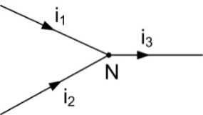

**Fig. 1a**

Determine:

a) the r.m.s value, the initial phase and the instantaneous value of the current ${\text{i}}_{\text{3}}$;

b) represent the phasor diagram of the currents.

1. The complex values of the current will be:

$${\text{i}}_{\text{1}}\text{=6}\text{sin}{\text{(}\text{ω}\text{t+}\frac{\text{π}}{\text{4}}\text{)}}\text{→}{\underline{\text{I}}}_{\text{1}}\text{=}\frac{\text{6}}{\sqrt{\text{2}}}{\text{e}}^{\text{j}\frac{\text{π}}{\text{4}}}\text{=3}\sqrt{\text{2}}\text{(cos }\frac{\text{π}}{\text{4}}\text{+jsin}{\frac{\text{π}}{\text{4}}}\text{)=3}\sqrt{\text{2}}\text{∙}\frac{\sqrt{\text{2}}}{\text{2}}\left(\text{1+j}\right)\text{=3(1+j).}$$

$${\text{i}}_{\text{2}}\text{=6}\text{cos}{\text{(}\text{ω}\text{t+}\frac{\text{π}}{\text{4}}\text{)=6}\text{sin}{\text{(}\text{ω}\text{t+}\frac{\text{π}}{\text{4}}\text{+}\frac{\text{π}}{\text{2}}\text{)=6}\text{sin}{\text{(}\text{ω}\text{t+}\frac{\text{3π}}{\text{4}}\text{)}}}}\text{;}$$

$${\underline{\text{I}}}_{\text{2}}\text{=}\frac{\text{6}}{\sqrt{\text{2}}}{\text{e}}^{\text{j}\frac{\text{3π}}{\text{4}}}\text{=}\frac{\text{6}}{\sqrt{\text{2}}}\text{(cos }\frac{\text{3π}}{\text{4}}\text{+jsin}{\frac{\text{3π}}{\text{4}}}\text{)=}\frac{\text{6}}{\sqrt{\text{2}}}\text{∙}\text{(-}\frac{\sqrt{\text{2}}}{\text{2}}\text{+j}\frac{\sqrt{\text{2}}}{\text{2}}\text{)=3(-1+j).}$$

$${\underline{\text{I}}}_{\text{3}}\text{=}{\underline{\text{I}}}_{\text{1}}\text{+}{\underline{\text{I}}}_{\text{2}}\text{=3(1+j)+3(-1+j)=6j.}$$

The r.m.s value of the current will be:

$${\text{I}}_{\text{3}}\text{=}\sqrt{{\text{I}}_{\text{1}}^{\text{2}}\text{+}{\text{I}}_{\text{2}}^{\text{2}}\text{+2}{\text{I}}_{\text{1}}{\text{I}}_{\text{2}}\text{cos(}{\text{α}}_{\text{1}}\text{-}{\text{α}}_{\text{2}}\text{)}}\text{=}\sqrt{{\left(\frac{\text{6}}{\sqrt{\text{2}}}\right)}^{\text{2}}\text{+}{\left(\frac{\text{6}}{\sqrt{\text{2}}}\right)}^{\text{2}}\text{+2}\frac{\text{6}}{\sqrt{\text{2}}}\text{∙}\frac{\text{6}}{\sqrt{\text{2}}}\text{cos(}\frac{\text{π}}{\text{4}}\text{-}\frac{\text{3π}}{\text{4}}\text{)}}\text{=}\sqrt{\text{18+18+36}\text{cos(-}\frac{\text{π}}{\text{2}}\text{)}}\text{=}\sqrt{\text{36}}\text{=6.}$$

The initial phase is:

$${\text{φ}}_{\text{3}}\text{=arctg}\frac{{\text{I}}_{\text{1}}\text{sin}{\text{α}}_{\text{1}}\text{+}{\text{I}}_{\text{2}}\text{sin}{\text{α}}_{\text{2}}}{{\text{I}}_{\text{1}}\text{cos}{\text{α}}_{\text{1}}\text{+}{\text{I}}_{\text{2}}\text{cos}{\text{α}}_{\text{2}}}\text{=arctg}\frac{\frac{\text{6}}{\sqrt{\text{2}}}\text{sin}\frac{\text{π}}{\text{4}}\text{+}\frac{\text{6}}{\sqrt{\text{2}}}\text{sin}\frac{\text{3π}}{\text{4}}}{\frac{\text{6}}{\sqrt{\text{2}}}\text{cos}\frac{\text{π}}{\text{4}}\text{+}\frac{\text{6}}{\sqrt{\text{2}}}\text{cos}\frac{\text{3π}}{\text{4}}}\text{;}$$

$${\text{φ}}_{\text{3}}\text{=arctg}\frac{\text{sin}\frac{\text{π}}{\text{4}}\text{+}\text{sin}\frac{\text{3π}}{\text{4}}}{\text{cos}\frac{\text{π}}{\text{4}}\text{+}\text{cos}\frac{\text{3π}}{\text{4}}}\text{=}\text{arctg}\frac{\frac{\sqrt{\text{2}}}{\text{2}}\text{+}\frac{\sqrt{\text{2}}}{\text{2}}}{\frac{\sqrt{\text{2}}}{\text{2}}\text{-}\frac{\sqrt{\text{2}}}{\text{2}}}\text{= arctg ∞=}\frac{\text{π}}{\text{2}}\text{.}$$

$${\text{i}}_{\text{3}}\text{=}{\text{I}}_{\text{3}}\sqrt{\text{2}}\text{sin}\left(\text{ω}\text{t+}\text{α}\right)\text{=6}\sqrt{\text{2}}\text{sin}{\text{(}\text{ω}\text{t}}\text{+}\frac{\text{π}}{\text{2}}\text{).}$$

b) The phasor diagram is represented in figure 1b.

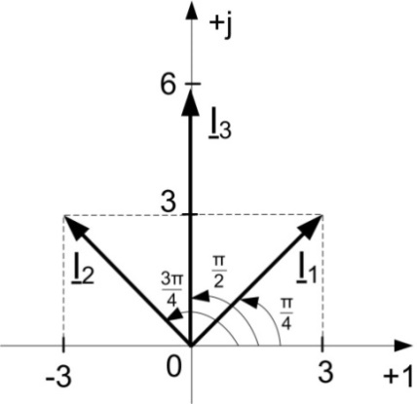

**Fig. 1b**

4. Transform the instantaneous values of the below currents into complex and represent the phasor diagram.

$${\text{a) i}}_{\text{1}}\text{=6}\text{sin}{\text{(}\text{ω}\text{t+}\frac{\text{π}}{\text{6}}\text{)}}\text{;}{\text{b) i}}_{\text{2}}\text{=-6}\text{sin}{\text{(}\text{ω}\text{t+}\frac{\text{π}}{\text{4}}\text{)}}\text{;}{\text{c) i}}_{\text{3}}\text{=6}\text{cos}{\text{(}\text{ω}\text{t+}\frac{\text{π}}{\text{6}}\text{)}}\text{;}$$

$${\text{d) i}}_{\text{4}}\text{=}\text{-}\text{6}\sqrt{\text{2}}\text{cos}{\text{(}\text{ω}\text{t+}\frac{\text{π}}{\text{4}}\text{)}}\text{.}$$

**Solving**

$${\text{a) i}}_{\text{1}}\text{=6}\text{sin}{\text{(}\text{ω}\text{t+}\frac{\text{π}}{\text{6}}\text{)}}\text{;}$$

$${\underline{\text{I}}}_{\text{1}}\text{=}\frac{\text{6}}{\sqrt{\text{2}}}{\text{e}}^{\text{j}\frac{\text{π}}{\text{6}}}\text{=}\frac{\text{6}}{\sqrt{\text{2}}}\text{(cos }\frac{\text{π}}{\text{6}}\text{+jsin}{\frac{\text{π}}{\text{6}}}\text{)=}\frac{\text{6}}{\sqrt{\text{2}}}\text{(}\frac{\sqrt{\text{3}}}{\text{2}}\text{+j}\frac{\text{1}}{\text{2}}\text{)=}\frac{\text{3}}{\sqrt{\text{2}}}\text{(}\sqrt{\text{3}}\text{+j).}$$

$${\text{b) i}}_{\text{2}}\text{=6}\text{sin}{\text{(π+}\text{ω}\text{t+}\frac{\text{π}}{\text{4}}\text{)}}\text{=}\text{6}\text{sin}{\text{(}\text{ω}\text{t+}\frac{\text{5π}}{\text{4}}\text{)}}\text{;}$$

$${\underline{\text{I}}}_{\text{2}}\text{=}\frac{\text{6}}{\sqrt{\text{2}}}{\text{e}}^{\text{j}\frac{\text{5π}}{\text{4}}}\text{=}\frac{\text{6}}{\sqrt{\text{2}}}\text{(cos }\frac{\text{5π}}{\text{4}}\text{+jsin}{\frac{\text{5π}}{\text{4}}}\text{)=}\frac{\text{6}}{\sqrt{\text{2}}}\text{(-}\frac{\sqrt{\text{2}}}{\text{2}}\text{-j}\frac{\sqrt{\text{2}}}{\text{2}}\text{)=3(-1-j).}$$

$${\text{c) i}}_{\text{3}}\text{=6}\text{cos}{\text{(}\text{ω}\text{t+}\frac{\text{π}}{\text{6}}\text{)=6}\text{sin}{\text{(}\text{ω}\text{t+}\frac{\text{π}}{\text{6}}\text{+}\frac{\text{π}}{\text{2}}\text{)}}\text{=}}\text{6}\text{sin}{\text{(}\text{ω}\text{t+}\frac{\text{2π}}{\text{3}}\text{)}}\text{;}$$

$${\underline{\text{I}}}_{\text{3}}\text{=}\frac{\text{6}}{\sqrt{\text{2}}}{\text{e}}^{\text{j}\frac{\text{2π}}{\text{3}}}\text{=}\frac{\text{6}}{\sqrt{\text{2}}}\text{(cos }\frac{\text{2π}}{\text{3}}\text{+jsin}{\frac{\text{2π}}{\text{3}}}\text{)=}\frac{\text{6}}{\sqrt{\text{2}}}\text{(-}\frac{\text{1}}{\text{2}}\text{+j}\frac{\sqrt{\text{3}}}{\text{2}}\text{)=}\frac{\text{3}}{\sqrt{\text{2}}}\text{(-1+j}\sqrt{\text{3}}\text{).}$$

$${\text{d) i}}_{\text{4}}\text{=6}\sqrt{\text{2}}\text{cos}{\text{(π+}\text{ω}\text{t+}\frac{\text{π}}{\text{4}}\text{)}}\text{=}\text{6}\sqrt{\text{2}}\text{cos}{\text{(}\text{ω}\text{t+}\frac{\text{5π}}{\text{4}}\text{)}}\text{=}\text{6}\sqrt{\text{2}}\text{sin}{\text{(}\text{ω}\text{t+}\frac{\text{π}}{\text{2}}\text{+}\frac{\text{5π}}{\text{4}}\text{)}}\text{=}$$

$$\text{=6}\sqrt{\text{2}}\text{sin}{\text{(}\text{ω}\text{t+}\frac{\text{7π}}{\text{4}}\text{)}}\text{;}$$

$${\underline{\text{I}}}_{\text{4}}\text{=}\frac{\text{6}\sqrt{\text{2}}}{\sqrt{\text{2}}}{\text{e}}^{\text{j}\frac{\text{7π}}{\text{4}}}\text{=6(cos}\frac{\text{7π}}{\text{4}}\text{+jsin}{\frac{\text{7π}}{\text{4}}}\text{)=6}\text{(}\frac{\sqrt{\text{2}}}{\text{2}}\text{-j}\frac{\sqrt{\text{2}}}{\text{2}}\text{)=3}\sqrt{\text{2}}\text{(1-j).}$$

The phasor diagram is represented in figure 2.

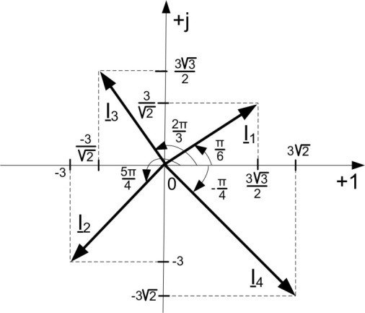

**Fig. 2**

Knowing the circuit bellow determine the equivalent impedance of the circuit, the instantanous value of the current in the circuit, the voltage drops on the elements and the phasors diagram of the circuit.

$$R=3 Ω; L=\frac{40}{π}mH; C=\frac{10}{π}mF; u=300\sin\left(314t-\frac{π}{4}\right).$$

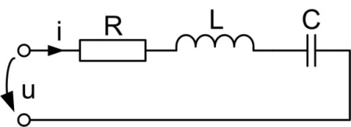

**Fig. 3a**

**Solution $${\underline{Z}}_{e}=R+jωL+\frac{1}{jωC}=3+j∙314∙\frac{40}{π}∙{10}^{-3}+\frac{1}{j∙314∙\frac{10}{π}∙{10}^{-3}}=3+4j-j=3(1+j).$$**

$$\underline{I}=\frac{\underline{U}}{{\underline{Z}}_{e}}=\frac{\frac{300}{\sqrt{2}}e^{-j\frac{π}{4}}}{3(1+j)}=\frac{150(1-j)}{3(1+j)}=\frac{50{(1-j)}^{2}}{2}=25\left(1-2j-1\right)=-50j.$$

$$i=50\sqrt{2}\sin\left(314t-\frac{π}{2}\right) [A].$$

$${\underline{U}}_{R}=R∙\underline{I}=3∙(-50j)=-150j→u_{R}=150\sqrt{2}\sin\left(314t-\frac{π}{2}\right) [V].$$

$${\underline{U}}_{L}=jωL∙\underline{I}=4j∙(-50j)=200→u_{L}=200\sqrt{2}sin 314t{ [V].}$$

$${\underline{U}}_{C}=\frac{1}{jωC}∙\underline{I}=-j∙(-50j)=-50→u_{C}=50\sqrt{2}\sin\left(314t-π\right) [V].$$

The phasor’s diagram is in figure 3b..

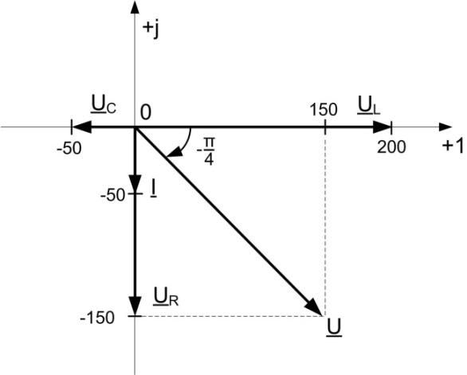

**Fig. 3b**